How to Test the Program

* System: Linux (Ubuntu 18.04 64bits)
* Environment requirements: install python 3 (python 2 is not supported)
* Steps:
  1. Put tester.py, phase1.py, phase2.py, test file and expected output file in a single same directory:

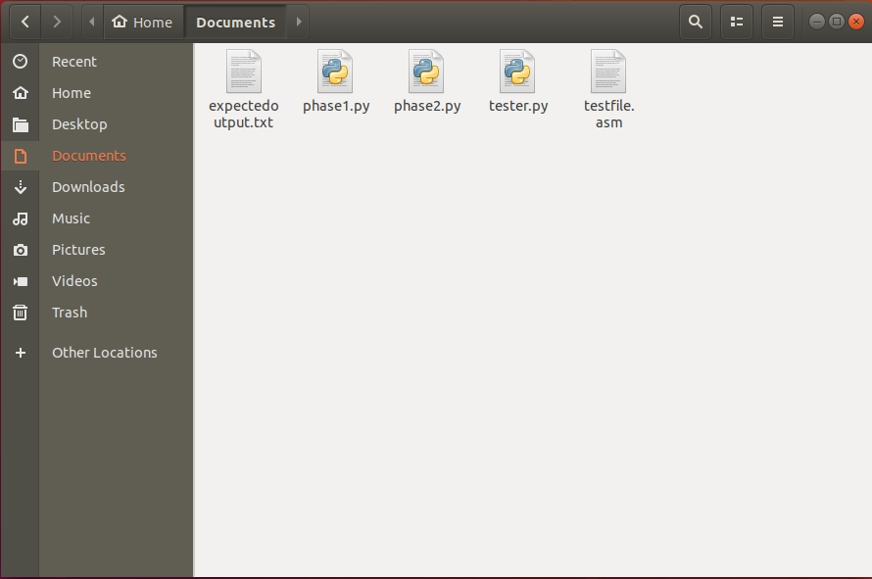

* 1. In the same directory you put the files, right-click and select “Open in terminal”, in order to limit the directory. (Notice: using the terminal for whole system or open terminal in other directory is not allowed, otherwise the program will not be able to find the matching files. If you insist to do so, you have to considering limit the directory by yourself.)

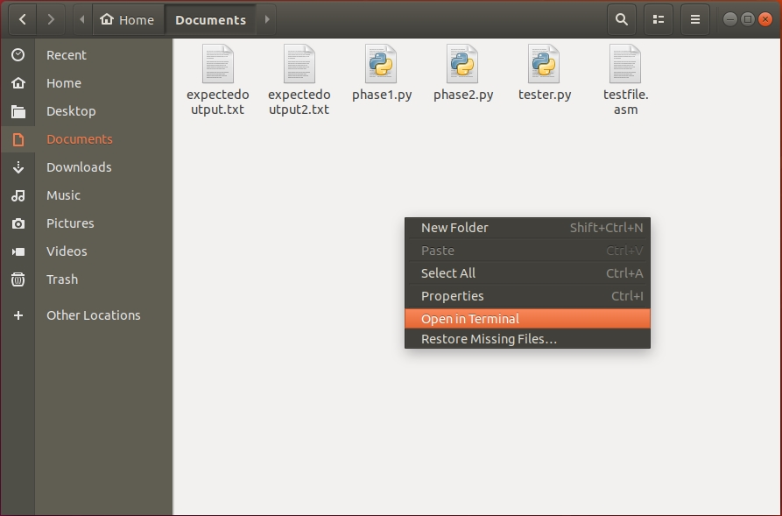

* 1. In the terminal, type in “python3 tester.py”.

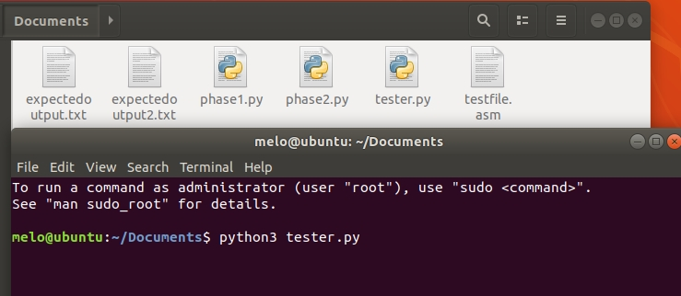

* 1. Then the program will ask the user to input the names of test file, output file and expected output file. Please input them. The program will check the input. If it finds that the test file or expected output file not exists in the same directory, it will ask the user to input again until it is correct.

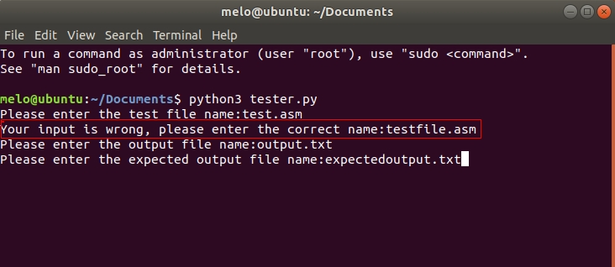

* 1. Finally, the program will produce an output file, and print the comparison result on the screen to tell the user whether the assembler pass the test.

